### **Soal Prioritas 2**

Buatlah test case untuk REST API berikut dengan menggunakan TestRail:

| **No** | **Endpoint** | **Method** | **Deskripsi** |
| --- | --- | --- | --- |
| 1 | <https://jsonplaceholder.typicode.com/posts> | GET | Mendapatkan semua data post. |
| 2 | <https://jsonplaceholder.typicode.com/posts> | POST | Membuat data post baru. |
| 3 | <https://jsonplaceholder.typicode.com/posts/1> | GET | Mendapatkan data post berdasarkan ID. |
| 4 | <https://jsonplaceholder.typicode.com/posts/1> | PUT | Mengubah data post berdasarkan ID. |
| 5 | <https://jsonplaceholder.typicode.com/posts/1> | DELETE | Menghapus data post berdasarkan ID. |

Kriteria dari pembuatan test case adalah sebagai berikut:

1. Terdapat case positif dan negatif.
2. Test case dibuat dengan menggunakan TestRail atau tools yang sejenis.
3. **Section : GET all post data**

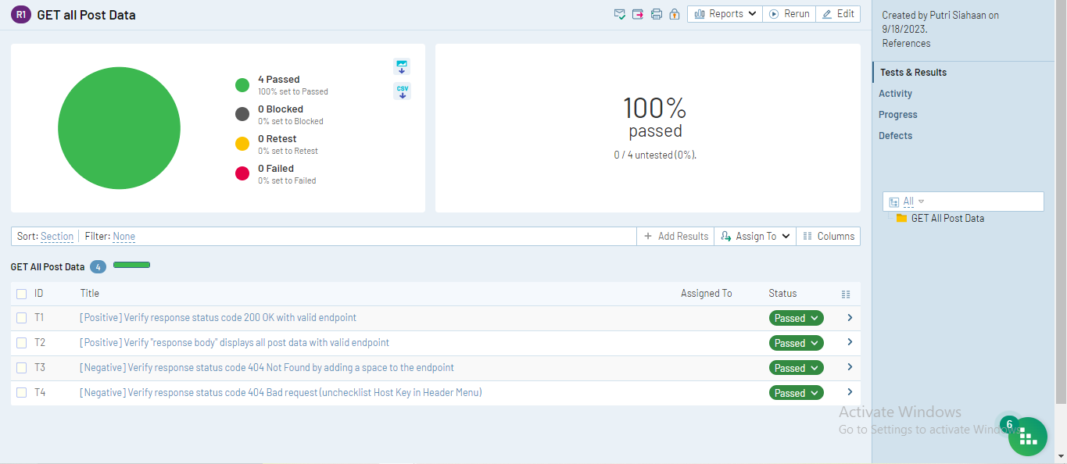

* **Verify response status code 200 OK with valid endpoint.**

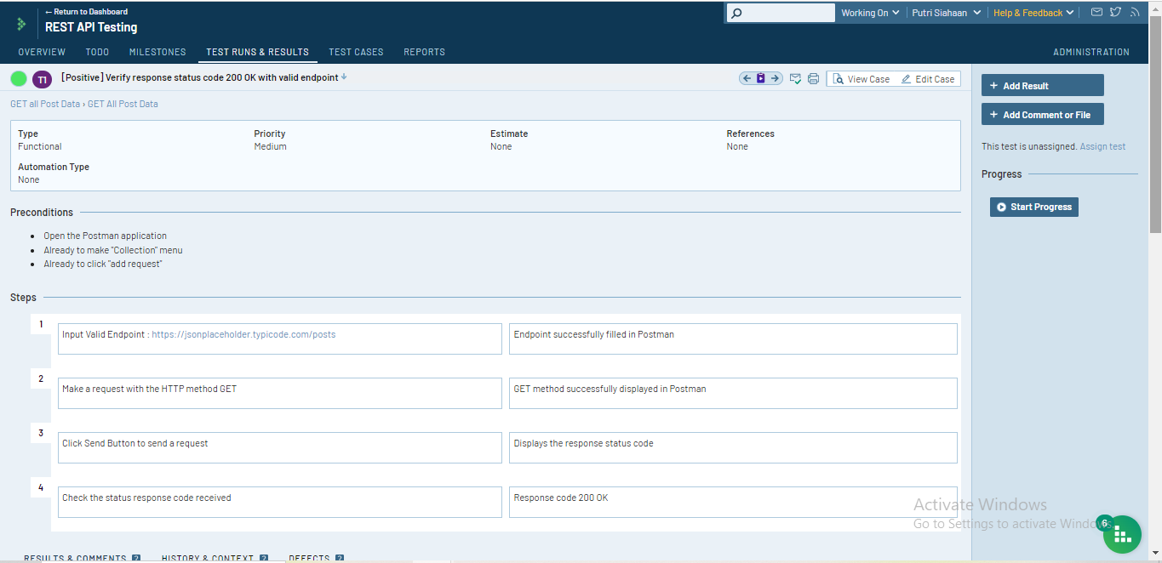

* **Verify "response body" displays all post data with valid endpoint**

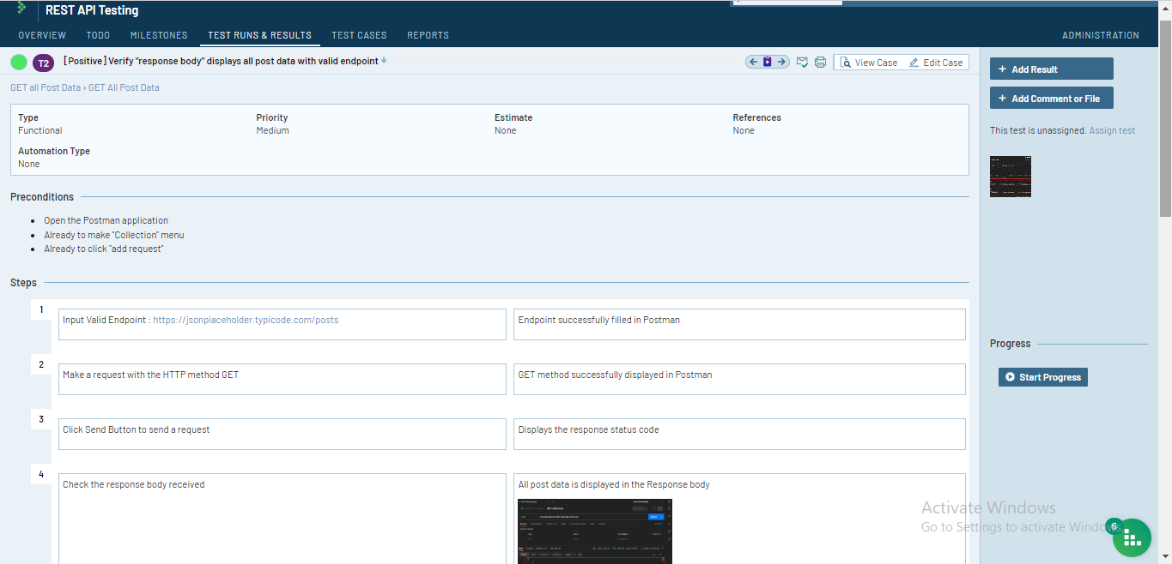

* **Verify response status code 404 Not Found by adding a space to the endpoint**

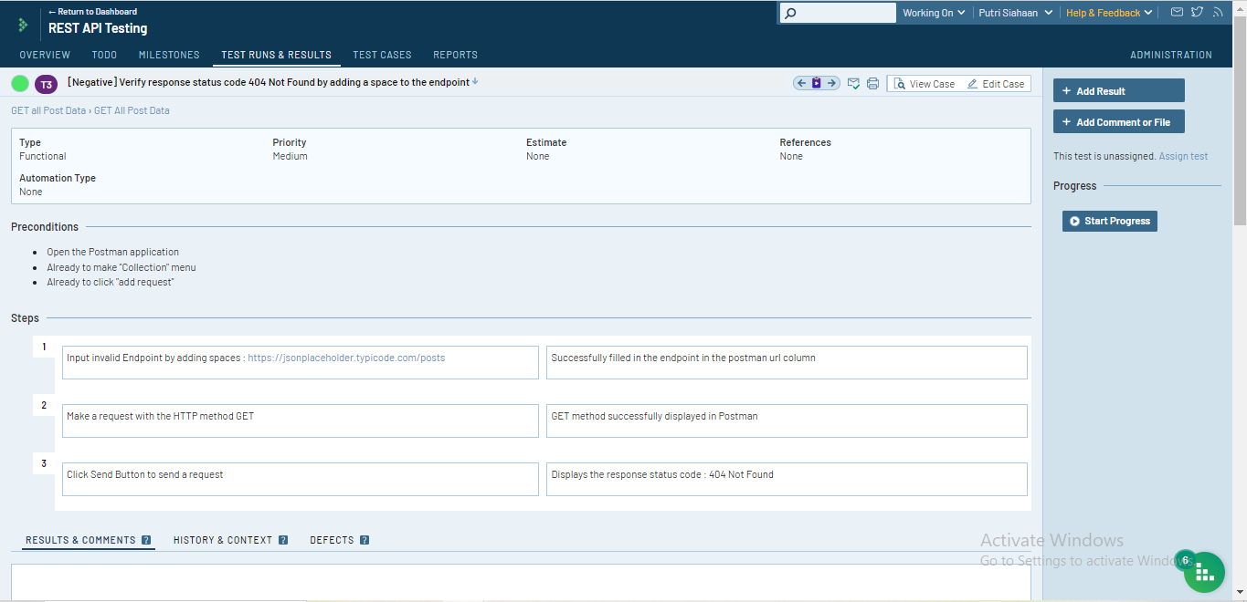

* **Verify response status code 404 Bad request (unchecklist Host Key in Header Menu)**

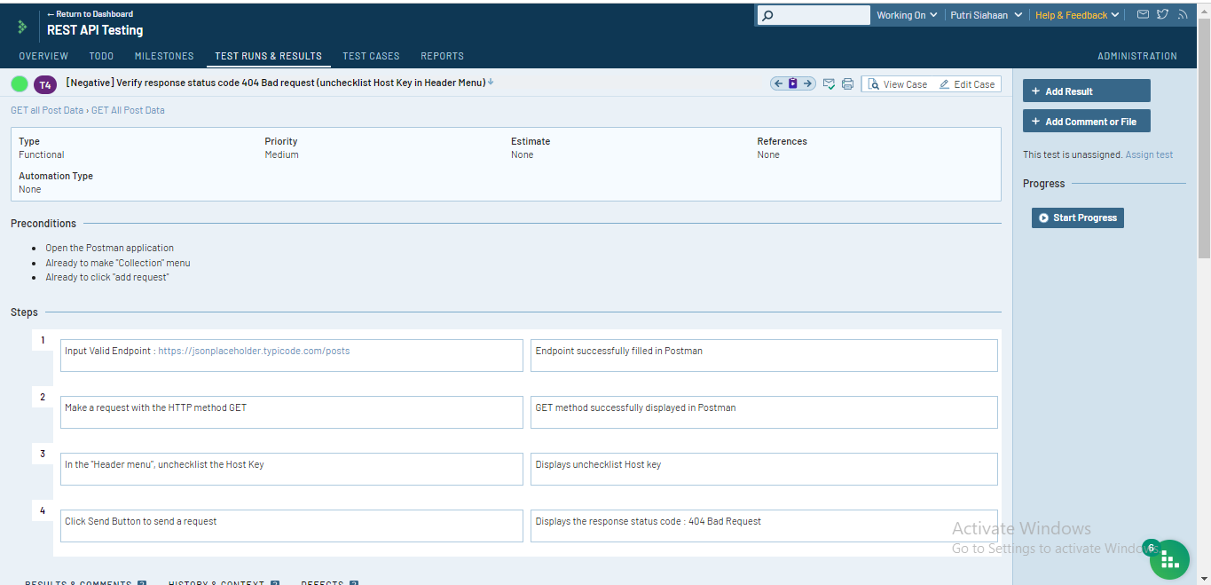

1. **Section : Create a new post data**

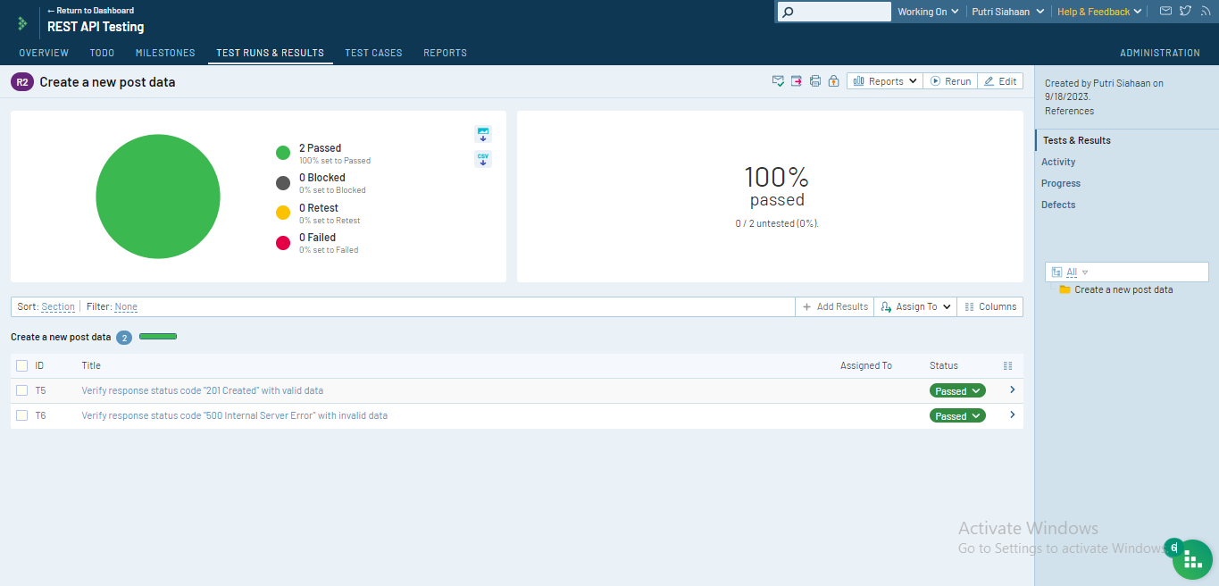

* **Verify response status code "201 Created" with valid data**

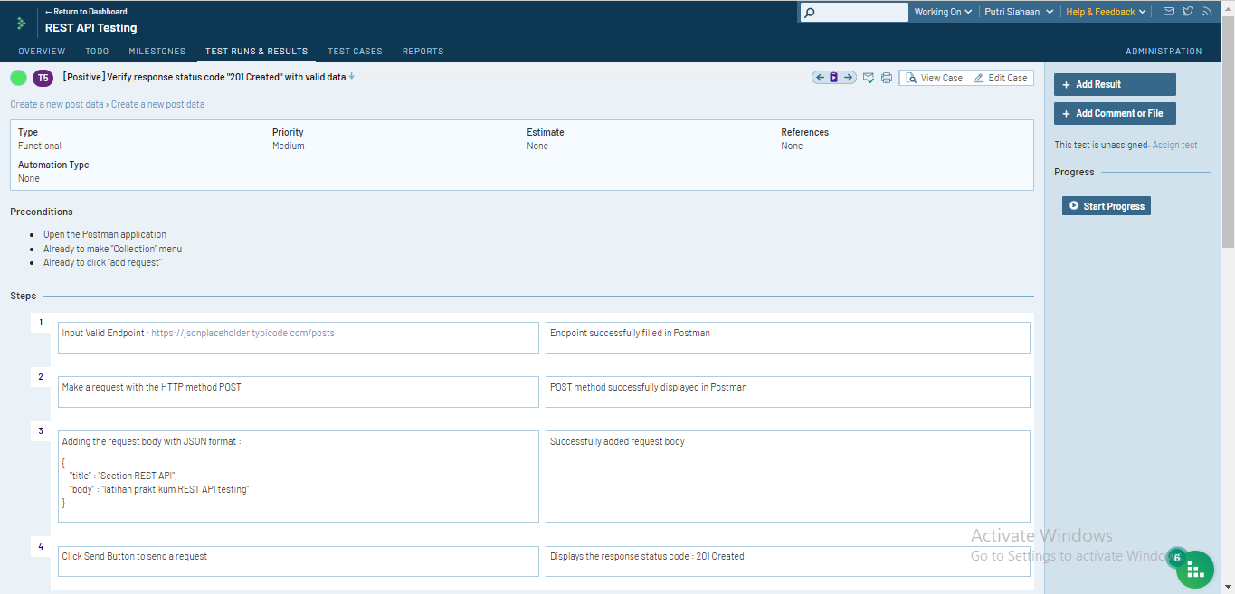

* **Verify response status code "500 Internal Server Error" with invalid data**

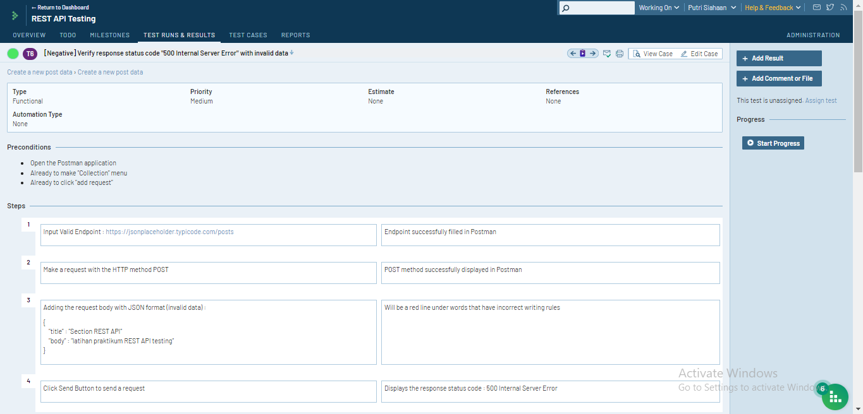

1. **Section : GET post data by ID**

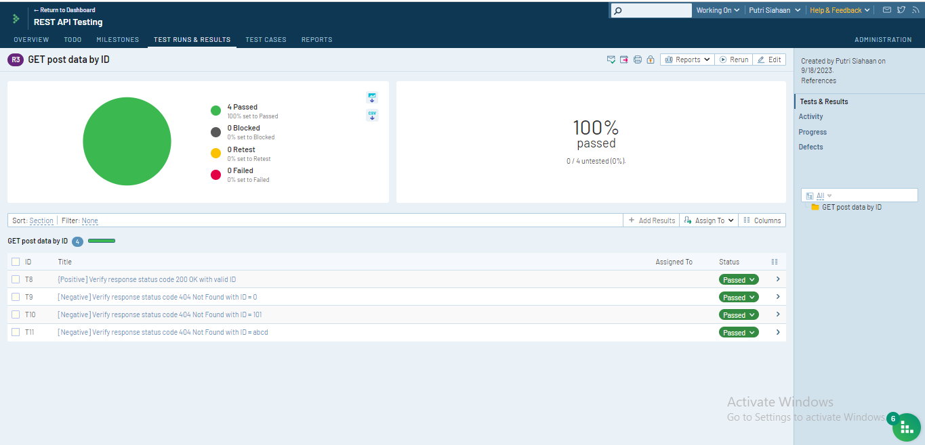

* **Verify response status code 200 OK with valid ID**

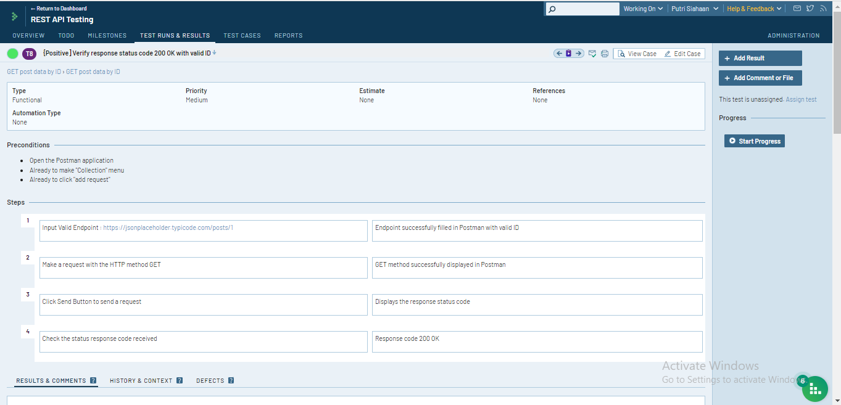

* **Verify response status code 404 Not Found with ID = 0**

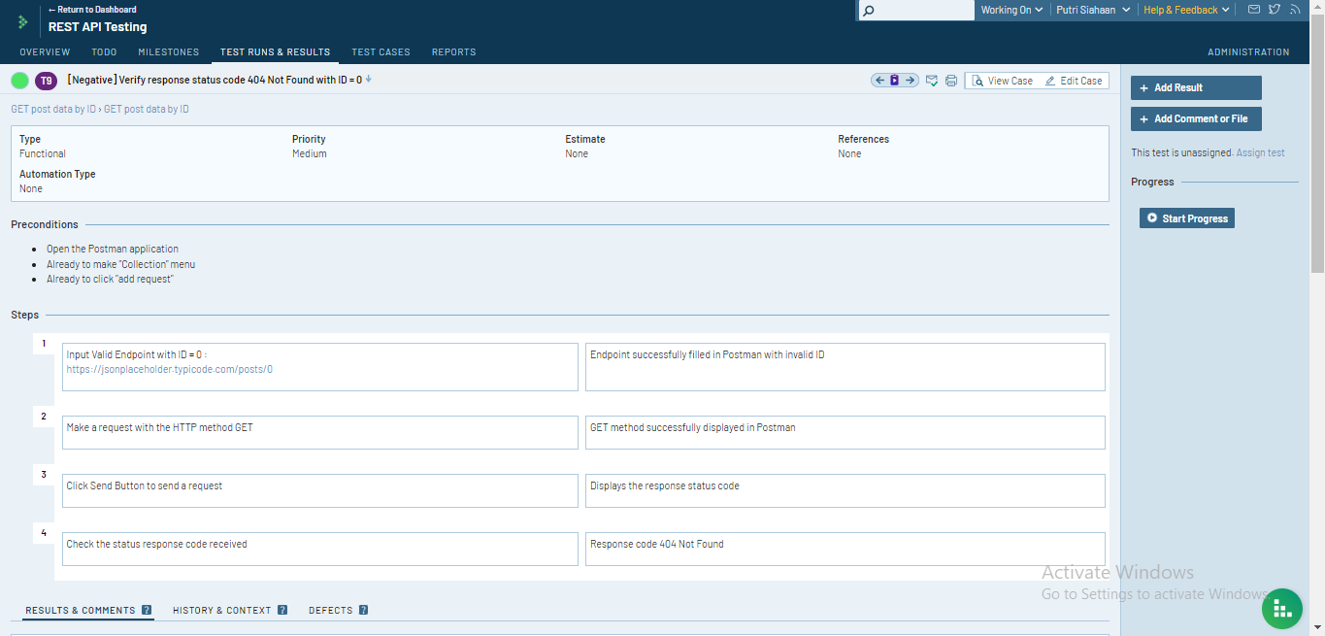

* **Verify response status code 404 Not Found with ID = 101**

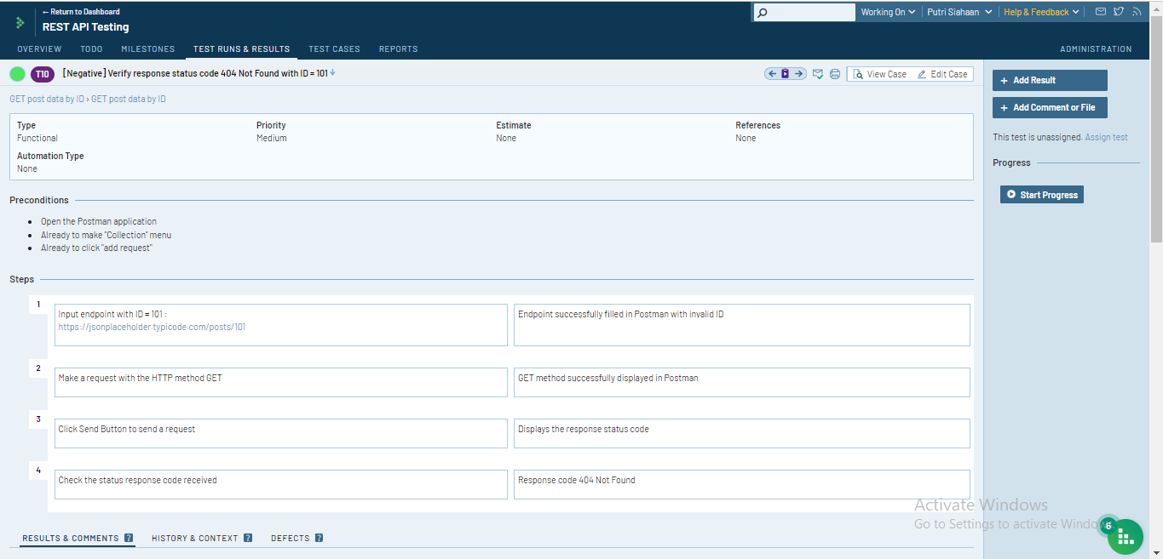

* **Verify response status code 404 Not Found with ID = abcd**

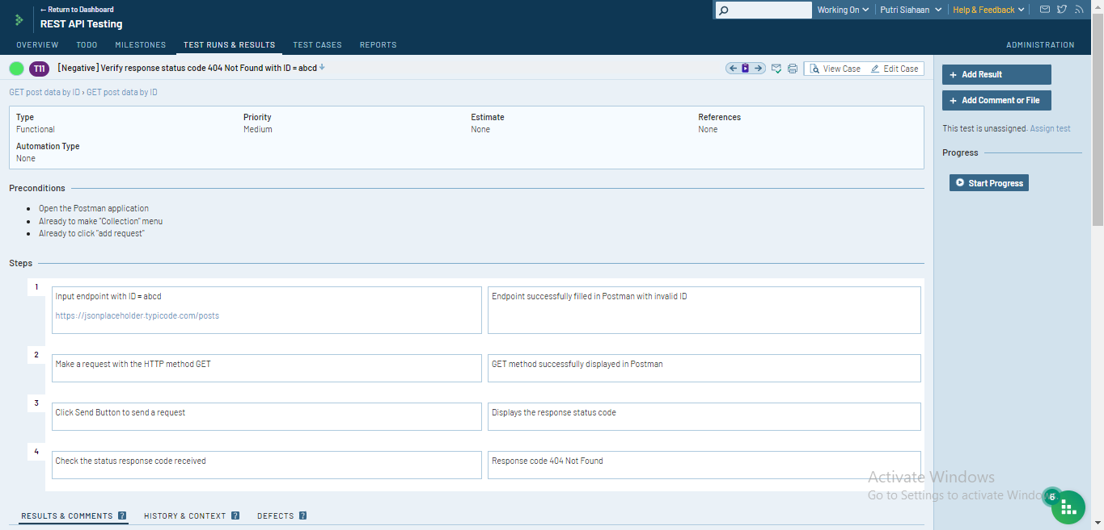

1. **Section : Changes post data by ID**

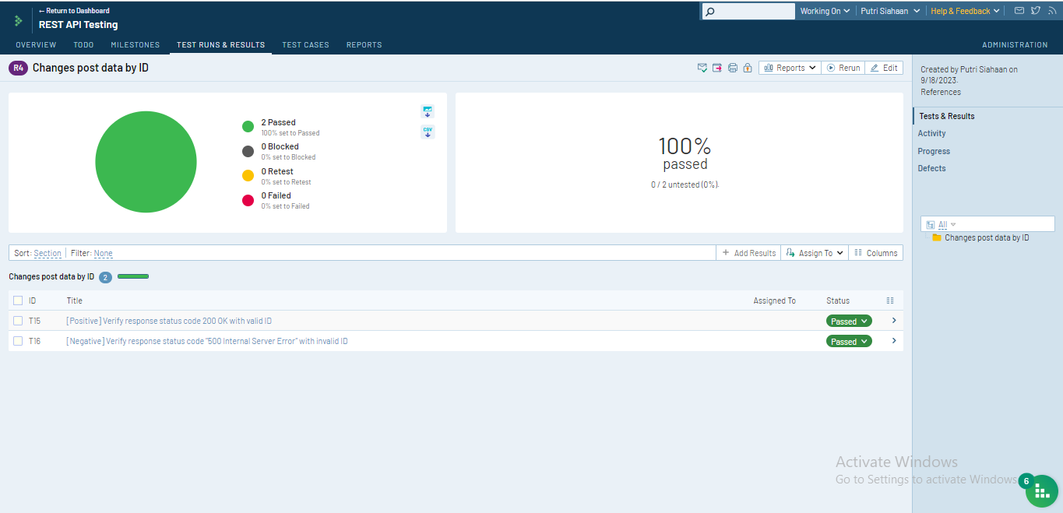

* Verify response status code 200 OK with valid ID

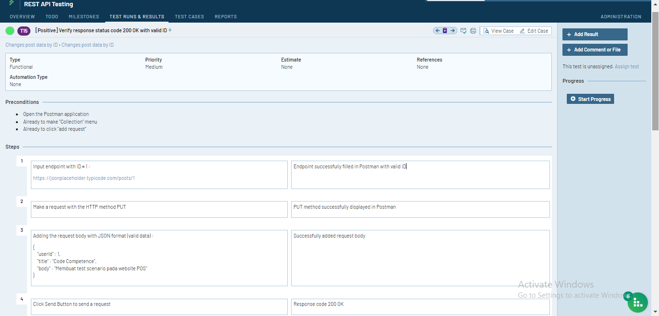

* Verify response status code "500 Internal Server Error" with invalid ID

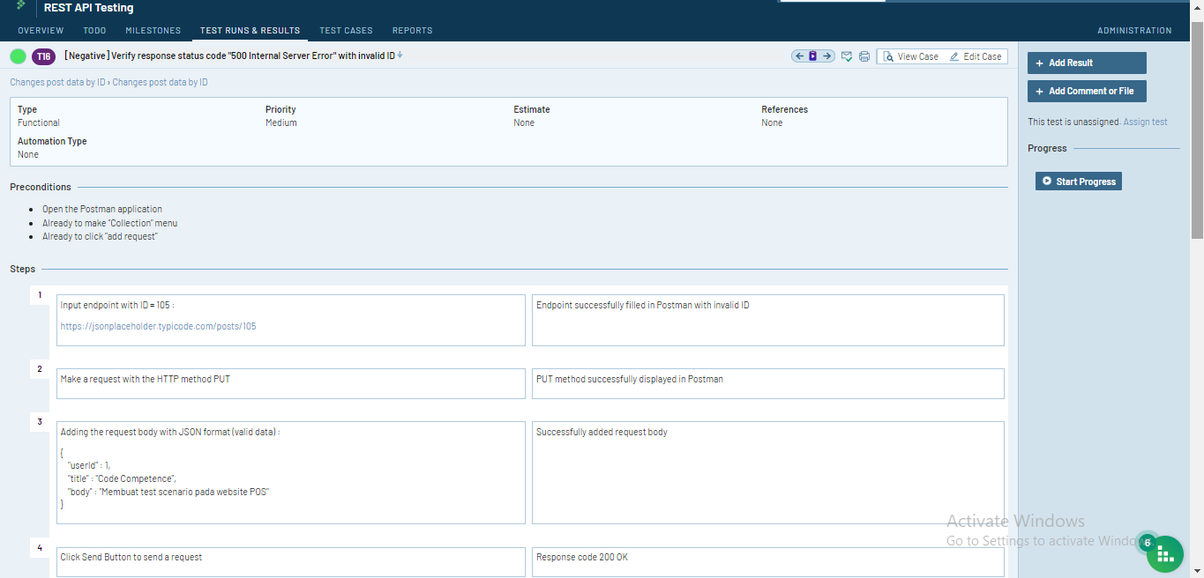

1. **Section : Delete post data by ID**

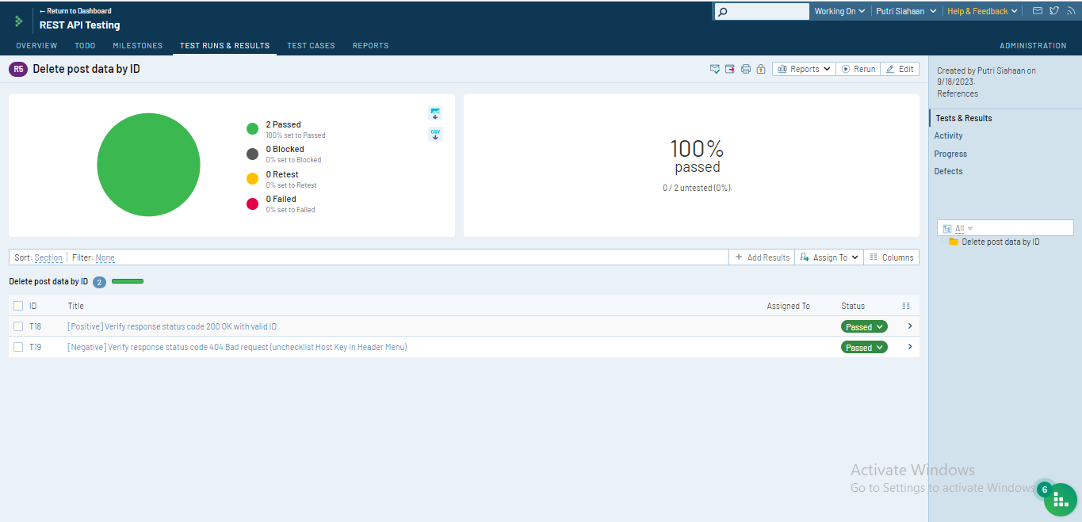

* Verify response status code 200 OK with valid ID

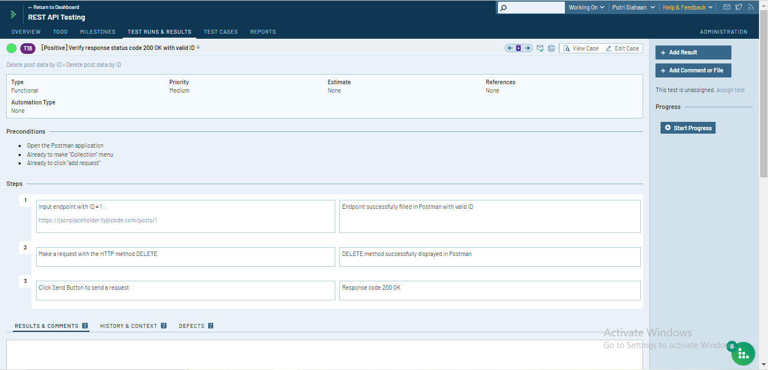

* Verify response status code 404 Bad request (unchecklist Host Key in Header Menu)

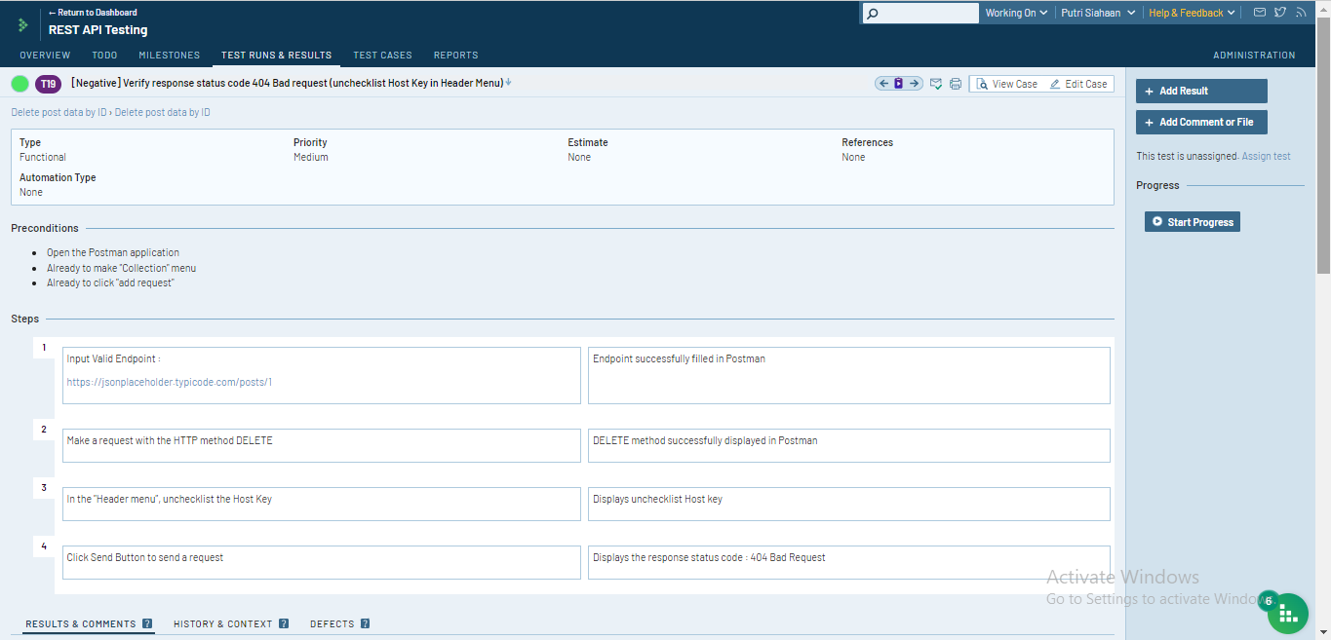

**TEST RUN & RESULT**